Screenshot of me SSHing into my Jump Box

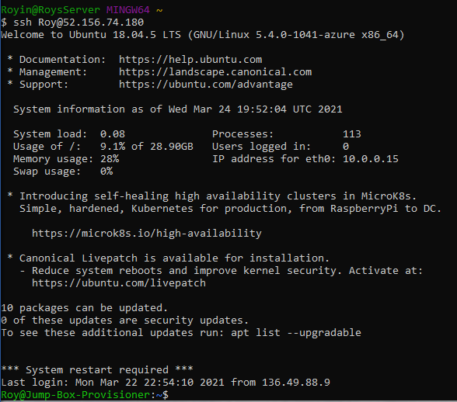

A screen shot of my listed containers

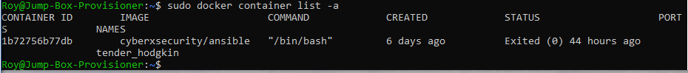

A screenshot of me starting my container

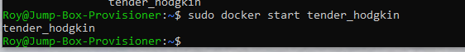

A screenshot of me attaching my container



A screenshot of me SSHing from my Jump Box to my Elk Stack Server

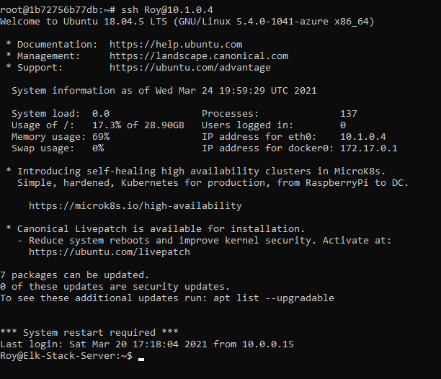

Screen shot of me showing the Elk Container

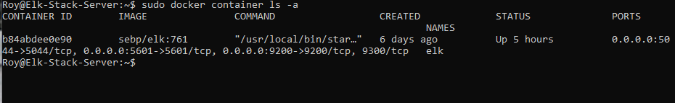

A screenshot showing the result of running `docker ps` after successfully configuring the ELK instance.

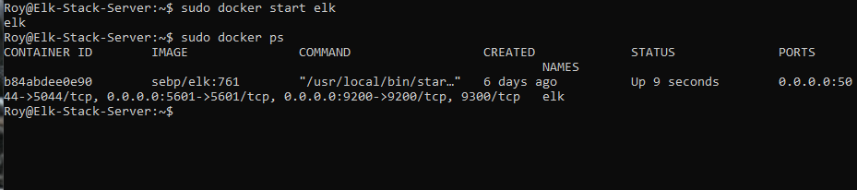

Me showing that running Elk worked

